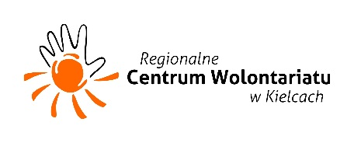

|  |
| --- |
|  |
| HELPING VOLUNTEERS |
|  |
| EVS in Poland, 1 September 2017 – 30 June 2018 |

***WHAT IS THE PROJECT ABOUT?***

The theme of the project is to work for development and promotion of local and European volunteering in the city of Kielce and region, development of young people through participation in "Bus Stop for Youth"  and empowering open attitudes and intercultural sensibility. The aim of the project is to increase social participation, especially in the form of volunteering: local and foreign (participation in EVS) among residents of Świętokrzyskie, especially young people, to encourage them to entrepreneurial attitude, involvement in youth policy, active participation in the creation of the cultural life of the city and the region. The key point is the personal development of EVS volunteers residing in Kielce. During their stay, volunteers will organize meetings and workshops for young people to promote volunteering and active, pro-social way of spending free time, they will participate in training and developing their skills in classes of Polish language and culture, they will provide support for young people who want to pursue their own initiative.

***WHAT WILL VOLUNTEERS DO?***

* Travel around the region and organize presentation and workshops for school pupils and university students promoting volunteering and culture of the countries volunteers are from
* Helping in daily work of the Volunteers Centre
* Holding language and hobby workshops (that will be decided with the volunteers) in the youth centre
* Organizing monthly parties for foreigners living in Kielce
* Implementing your own ideas/local project
* Meet amazing people and have lots of fun☺

***WHAT ARE THE LIVING CONDITIONS AND COSTS?***

Volunteers are provided with money for travel, pocket money and money for food (monthly pocket and food – 185 EUR) as well as with accommodation and city transport tickets. Volunteers will also attend Polish language classes.

***WHO WILL TAKE PART?***

9- month EVS activity which will be attended by **five volunteers from Armenia, Ukraine, Turkey, Lithuania and Italy** is an extension of the previous EVS projects implemented by the Volunteer Center. We already have for volunteers and urgently searching for ONE more 😊

***WHO ARE WE LOOKING FOR?***

As the project requires promotion of volunteering we are looking for people age 17-30 with at least basic volunteer experience (local volunteering, scouting, community service etc…). Basic English is required.

**MORE INFORMATIONS: barabra.biskup@centrumwolontariatu.eu**

*INFO ABOUT PROJECT*